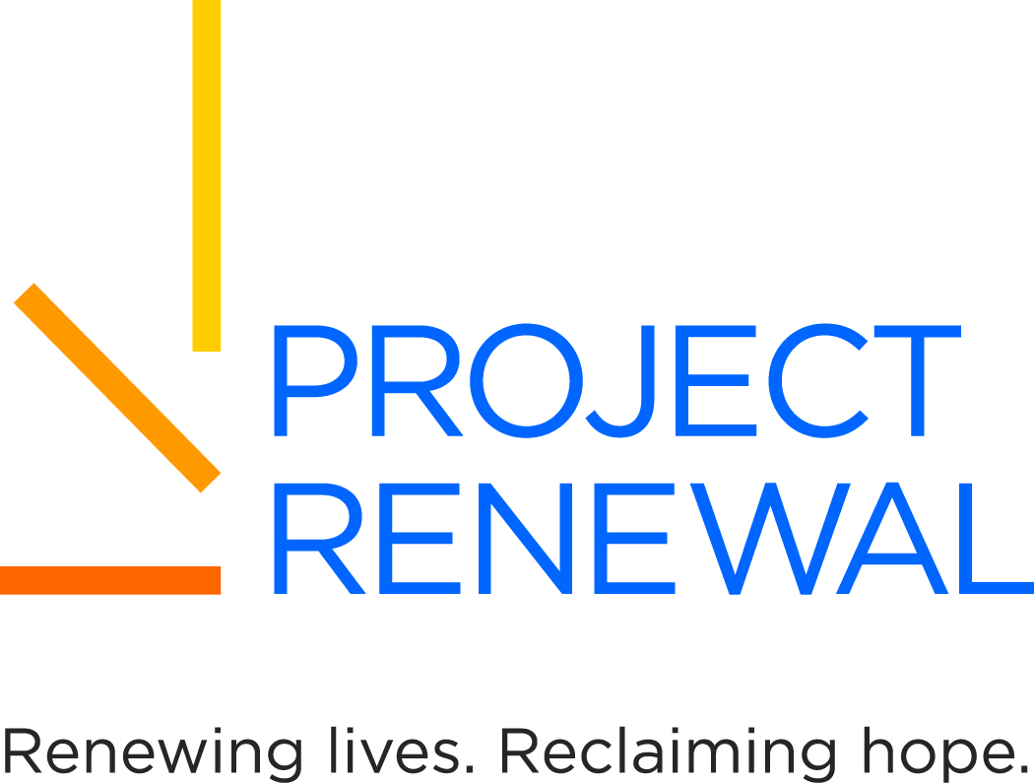

NEW YORK STATE
AMERICORPS MEMBER POSITION DESCRIPTION

Member Position / Title:
Health Educator/Patient Navigator
Member Immediate Supervisor Name: Position Start Date: Jennie Mejia 9/2019
Member Immediate Supervisor Title: Position End Date: Assistant Administrator of Healthcare Operations and Outreach 08/2020
Days / Hours of Service:
Monday thru Saturday between 7am and 9pm (flexible 35 hours/week)

Host Site Agency Name: Project Renewal
Address: 200 Varick Street
Address 2: 9th Floor
City: New York, NY Zip Code: 10014

Organization/Agency Mission and/or Goals:
Project Renewal Inc. is a nonprofit organization dedicated to ending homelessness in New York City. Its emphasis is on moving individuals from homelessness into housing while improving physical and mental health, assisting with job readiness and educational interventions to support independence.
Program Mission and/or Goals:
Project Renewal’s Primary Care Medical Program is a Federally Qualified Health Center providing primary care to homeless teens and adults by bringing services to homeless people where they live and congregate. Services are comprehensive and multidisciplinary, and care is provided with a team approach. The Program includes full-time Article 28 Diagnostic and Treatment Centers (clinics) operated on site at three different shelters in Manhattan, a full-time dental clinic at one of the shelters, and four mobile medical vans that are licensed clinics on wheels serving all of New York City. One of the mobile medical vans is a radiology van providing TB screening chest x-rays to homeless men and women, as well as screening mammograms and clinical breast exams to homeless and uninsured women. Psychiatric care is provided at primary care sites, and optometry is available as well. The program contains a case management program supporting individuals with HIV infection, and includes a large targeted outreach and HIV testing program. Alcohol and drug use screening and treatment is facilitated through referrals to Project Renewal’s detox and outpatient treatment programs.
Care is provided through collaborations with organizations serving homeless individuals, such as shelters, drop-in centers, and church-based meal programs. Medical vans visit host sites on a regular schedule so as to become sources of primary care that are comprehensive and reliable.
Community Need:
Homeless individuals in New York City have many barriers to addressing physical and behavioral health needs. Their lives are extremely unstable and they are at high risk for infectious diseases including HIV, TB, sexually transmitted infections and hepatitis. Those with chronic diseases such as diabetes, hypertension and asthma suffer higher morbidity and mortality related to their chronic diseases. Literacy levels are generally lower because of limited educational opportunities. Traditional sources of health care from hospitals to community clinics present access issues related to transportation barriers and difficulty managing appointments. The population has a very high prevalence of serious mental illness and substance abuse, requiring a focus on addressing these behavioral health issues as vital to providing comprehensive health care.
Effective April 1, 2012, all homeless individuals enrolled in Medicaid Managed Care, adding additional barriers to primary health care access. This will require an enormous effort to educate the population on choosing health plans, choosing a Primary Care Provider, and working with an insurance company for specialty referrals and emergencies.

Member Position Summary:
The Health Educator/Patient Navigator works as a member of the medical team to facilitate shelter residents’ access to health care. S/He promotes the available primary care services, speaks with groups of homeless individuals at the partnering sites to discuss health care services, and helps to reduce the multiple barriers encountered by this population. In the Health Educator role, s/he will assist in preparation of health workshops and work closely with the Health Education Specialist with the intent to independently run health workshops at various sites over the course of their time. In the Patient Navigator role, s/he will help the client successfully navigate the new managed care system through such tasks as identifying, referring and scheduling shelter residents in need of basic health services, including tuberculosis screening, comprehensive exams, screening and treatment of chronic illnesses. When the healthcare team identifies a particular patient of concern, the Patient Navigator will reach out to the patient and assume the role of patient advocate, assisting with transportation, translation, scheduling, and other supportive services. The Patient Navigator will work with both the medical team and site-based staff to identify opportunities to connect individuals to primary care. S/He will work with patients with complex illnesses who may require frequent appointments to the clinic or specialists, and will do so through confirming appointments, assisting with transportation, escorting, and obtaining records from outside medical providers.
Performance goals will include number of Health Education presentations, number of individual contacts, and number of medical visits generated as a result of outreach activities. Patient surveys will provide feedback on the impact on the program and on patient satisfaction.

Necessary Training or Training Plan to be implemented prior to Member Placement:
- Project Renewal will provide training on the following:
- Electronic Medical Record (eClinical Works)
- Eligibility and enrollment in Medicaid
- Medicaid Managed Care requirements
- Health literacy
- Quality Improvement Plan for prevention and management of chronic diseases
- New York City Department of Homeless Services requirements for housing placement

Member Impact:
Homeless individuals will be assisted to connect to primary care services in order to screen for and identify chronic conditions at an early stage when interventions improve outcomes. They will also be assisted to enroll in an insurance plan that provides improved access to care through a choice of the on site medical provider as the Primary Care Provider. They will also gain a better understanding of managing their own health care needs and learn to better advocate for themselves so their needs are met. Existing services provided by the Primary Care Program will be utilized more fully with increased numbers of patients and increased numbers of visits.
Essential Functions of Position:
- Meet with case management team at assigned sites to introduce the outreach activities.
- Promote the Primary Care Program’s services at assigned sites with group presentations and one-to-one contacts with clients.
- Offer assistance to clients related to choosing and enrolling in a Medicaid Managed Care plan.
- Meet with the Primary Care Medical team at the assigned sites to identify clients in need of focused outreach to improve compliance with primary care and specialty care appointments.
- Provide monthly reports on outreach activities by assigned site.
- Evaluate impact of outreach activities through patient and staff surveys and medical visit activity.

Required Knowledge, Skills, and Abilities:
- Working knowledge of computers including internet, Excel, and Word
- Communication skills for group presentations to individuals challenged with low educational achievement and mental illness.
- Ability to navigate around New York City on the public transportation system of subways and buses.
- Comfortable interacting with individuals suffering from mental illness, alcohol and/or other substance use.

Required Academic and Experience Qualifications:
- Two years of college.
- Bilingual English/Spanish preferred but not required.
- Experience working in a health care setting preferred but not required.

Does the AmeriCorps member serving in this position have recurring access to vulnerable populations?

No X Yes (Homeless Population)

See the following link for AmeriCorps Criminal Background Check requirements for members having recurring access to vulnerable populations. http://www.newyorkersvolunteer.ny.gov/NationalService/AmeriCorps.aspx#acLinks

