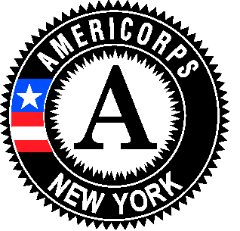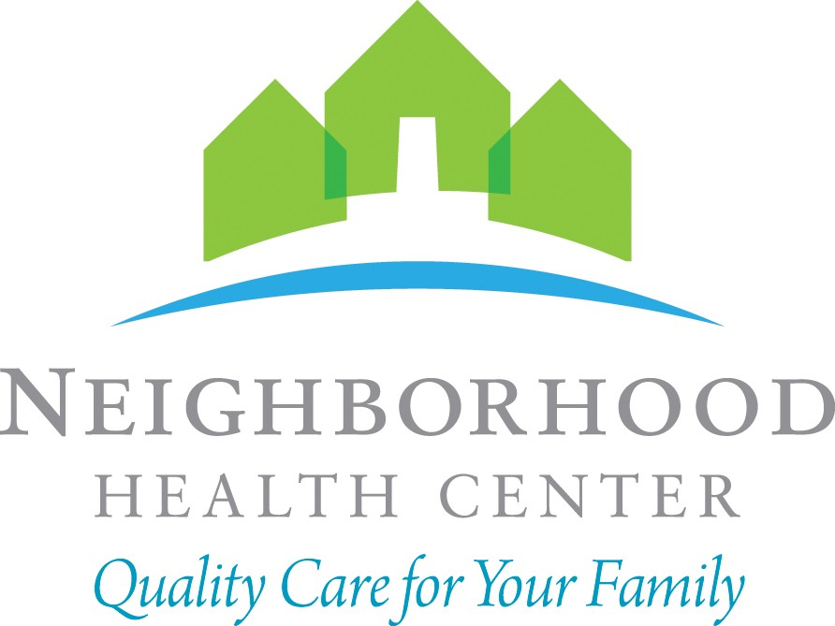

NEW YORK STATE
Site
Logo
AMERICORPS MEMBER POSITION DESCRIPTION

Member Position / Title: # of Member Slots in this Position:
Community Health Worker- Opioid Response Program 2

Member Immediate Supervisor Name: Position Start Date:
Merlyn Vilma September 2019

Member Immediate Supervisor Title: Position End Date:
Director of Public Health July 30, 2020

Days / Hours of Service:
Monday – Friday 9am-5pm / Hours vary to include some evenings and some Saturdays

Host Site Agency Name: Neighborhood Health Center

Address: 155 Lawn Ave

Address 2: Ste. 301

City: Buffalo, NY Zip Code: 14207

Organization/Agency Mission and/or Goals:

Neighborhood Health Center (NHC) is committed to providing accessible, close-to-home, efficient, and quality healthcare to individuals, families and communities of Western New York. Since 1987, NHC’s strategic intent to be a collective and integrated system of compassionate healthcare has been the driving force behind the organization’s growth and prosperity.

NHC’s mission is to provide comprehensive primary care services in adult care, dental care, pediatric care and women’s health. NHC also integrates supportive healthcare services, including pharmacy services, behavioral health, community health workers, nutrition and podiatry. More than 20,000 people receive care annually at our 4 health centers. This year, we expect our health professionals to provide for approximately 92,000 patient visits.

Program Mission and/or Goals:
Neighborhood Health Center is a nationally recognized Level III “patient-centered medical home,” (PCMH) a team- based approach to providing primary care. The care team is a partnership between the patient, their chosen primary care provider, nurses, support staff and other health care professionals. Together, the team uses evidence-based guidelines to provide the best health care services for patients’ specific health care needs. The care team also provides the tools that enable patients to better self-manage their health. The goal is to help patients stay as healthy as possible through better access to care, better understanding of their health, online access to their personal health information, and by coordinating their medical services with other health care providers (specialists and hospitals).
Community Need:
Death from opioid related overdoses is a national issue. According to the Center for Disease Control and Prevention (CDC), drug poisoning is the leading cause of injury-related mortality in the United State and was associated with 47,055 lives lost in 2014. In 2013, the latest full year for which data is available, the number of reported drug overdose deaths in New York State increased to 2,175, a 41% increase from 2009. The number of heroin-related deaths increased in 2013 to 637, and opioid analgesics related deaths rose to 952, increases of 163% and 30% from 2009, respectively. Concurrently, opioid-related emergency visits in New York State increased 73% from 2010 to 2014. 118,875 (42%) of the admissions to NYS certified substance abuse treatment programs in 2014 included “an opioid as the primary, secondary or tertiary drug problem, up 19 percent from 2010.”
Member Position Summary:
The Community Health Worker- Opioid Response program will support Neighborhood Health Center’s staff in researching, implementing, coordinating and assessing network Opioid initiatives and collaborating with community resources and health care teams for the purpose of improving and promoting patient wellness and prevention.
Participate in health promotion activities, a variety of one-on-one and group health education and patient advocacy services.

Necessary Training or Training Plan to be implemented prior to Member Placement:
Brief Intervention, and Referral to Treatment (SBIRT) model. The SBIRT model is an evidence-based intervention and has shown to have a measurable impact in the reduction and prevention of prescription drug and opioid abuse

Member Impact:
The impact of the position will increase communication and participation in our Opioid initiative that will assist clients with improving health outcomes and prevention.

Essential Functions of Position:
Major Duties and Responsibilities –
- Opioid and prescription drug use health education and care management
- Organize and promote opioid related workshops and trainings i.e. naloxone administration training for at risk patients and family members

- Conduct screenings and risk assessments of substance abuse for patients and in particular target patients on opioids prescriptions
- Provide targeted care management services to patients at risk of opioid and prescription drug abuse, provide follow up and support on treatment plans
- Raise awareness and reduce stigma by reaching out to the community i.e. schools, youth programs, and community programs
- Provide health education and promote overdose prevention
- Outreach to community programs increase patients’ knowledge of resources available and serve as liaison between health center resources, community resource programs, and family support groups
- Serve as Peer Mentors

Customer Service
  - Supports the Patient’s Bill of Rights/Responsibilities.
  - Protects the Patient’s right to dignity, privacy and confidentiality.
  - Able to communicate effectively both verbally and in writing with other staff, patients and providers.
  - Works to ensure a safe and pleasant environment of care.
  - Courteous toward all patients, co-workers and external customers.
  - Greets patients with a smile and shows outstanding customer service.
  - Has the ability to maintain harmonious professional relationship
    - with co-workers
    - between all departments

Professionalism
  - Acts in a professional manner in all dealings with patients, co-workers and external customers.
  - Is well groomed and follows dress code.
  - Is punctual and does not abuse work breaks and departure time.
  - Attends meetings according to departmental guidelines.
  - Represents the organization in a positive and professional manner in the community.
  - Complies with all organizational policies regarding ethical business practices.
  - Anticipates needs and shows initiative.
  - Demonstrates flexibility in meeting organizational needs.

Required Knowledge, Skills, and Abilities:
Must have good organizational skills and ability to handle multiple priorities and deadlines. Must be able to communicate effectively. Must be able to prioritize and cope with stress in a positive manner. Must be self- motivated and able to work independently. Must be proficient in Microsoft Office Applications and web-based applications. Ability to effectively present information and respond to questions from groups of managers.

Required Academic and Experience Qualifications:
Bachelor’s or Associates degree (A.A.) or equivalent from two-year college; or excess of two years related experience in the health care field experience; or equivalent combination of education and experience.

Does the AmeriCorps member serving in this position have recurring access to vulnerable populations?

No Yes

See the following link for AmeriCorps Criminal Background Check requirements for members having recurring access to vulnerable populations. http://www.newyorkersvolunteer.ny.gov/NationalService/AmeriCorps.aspx#acLinks

